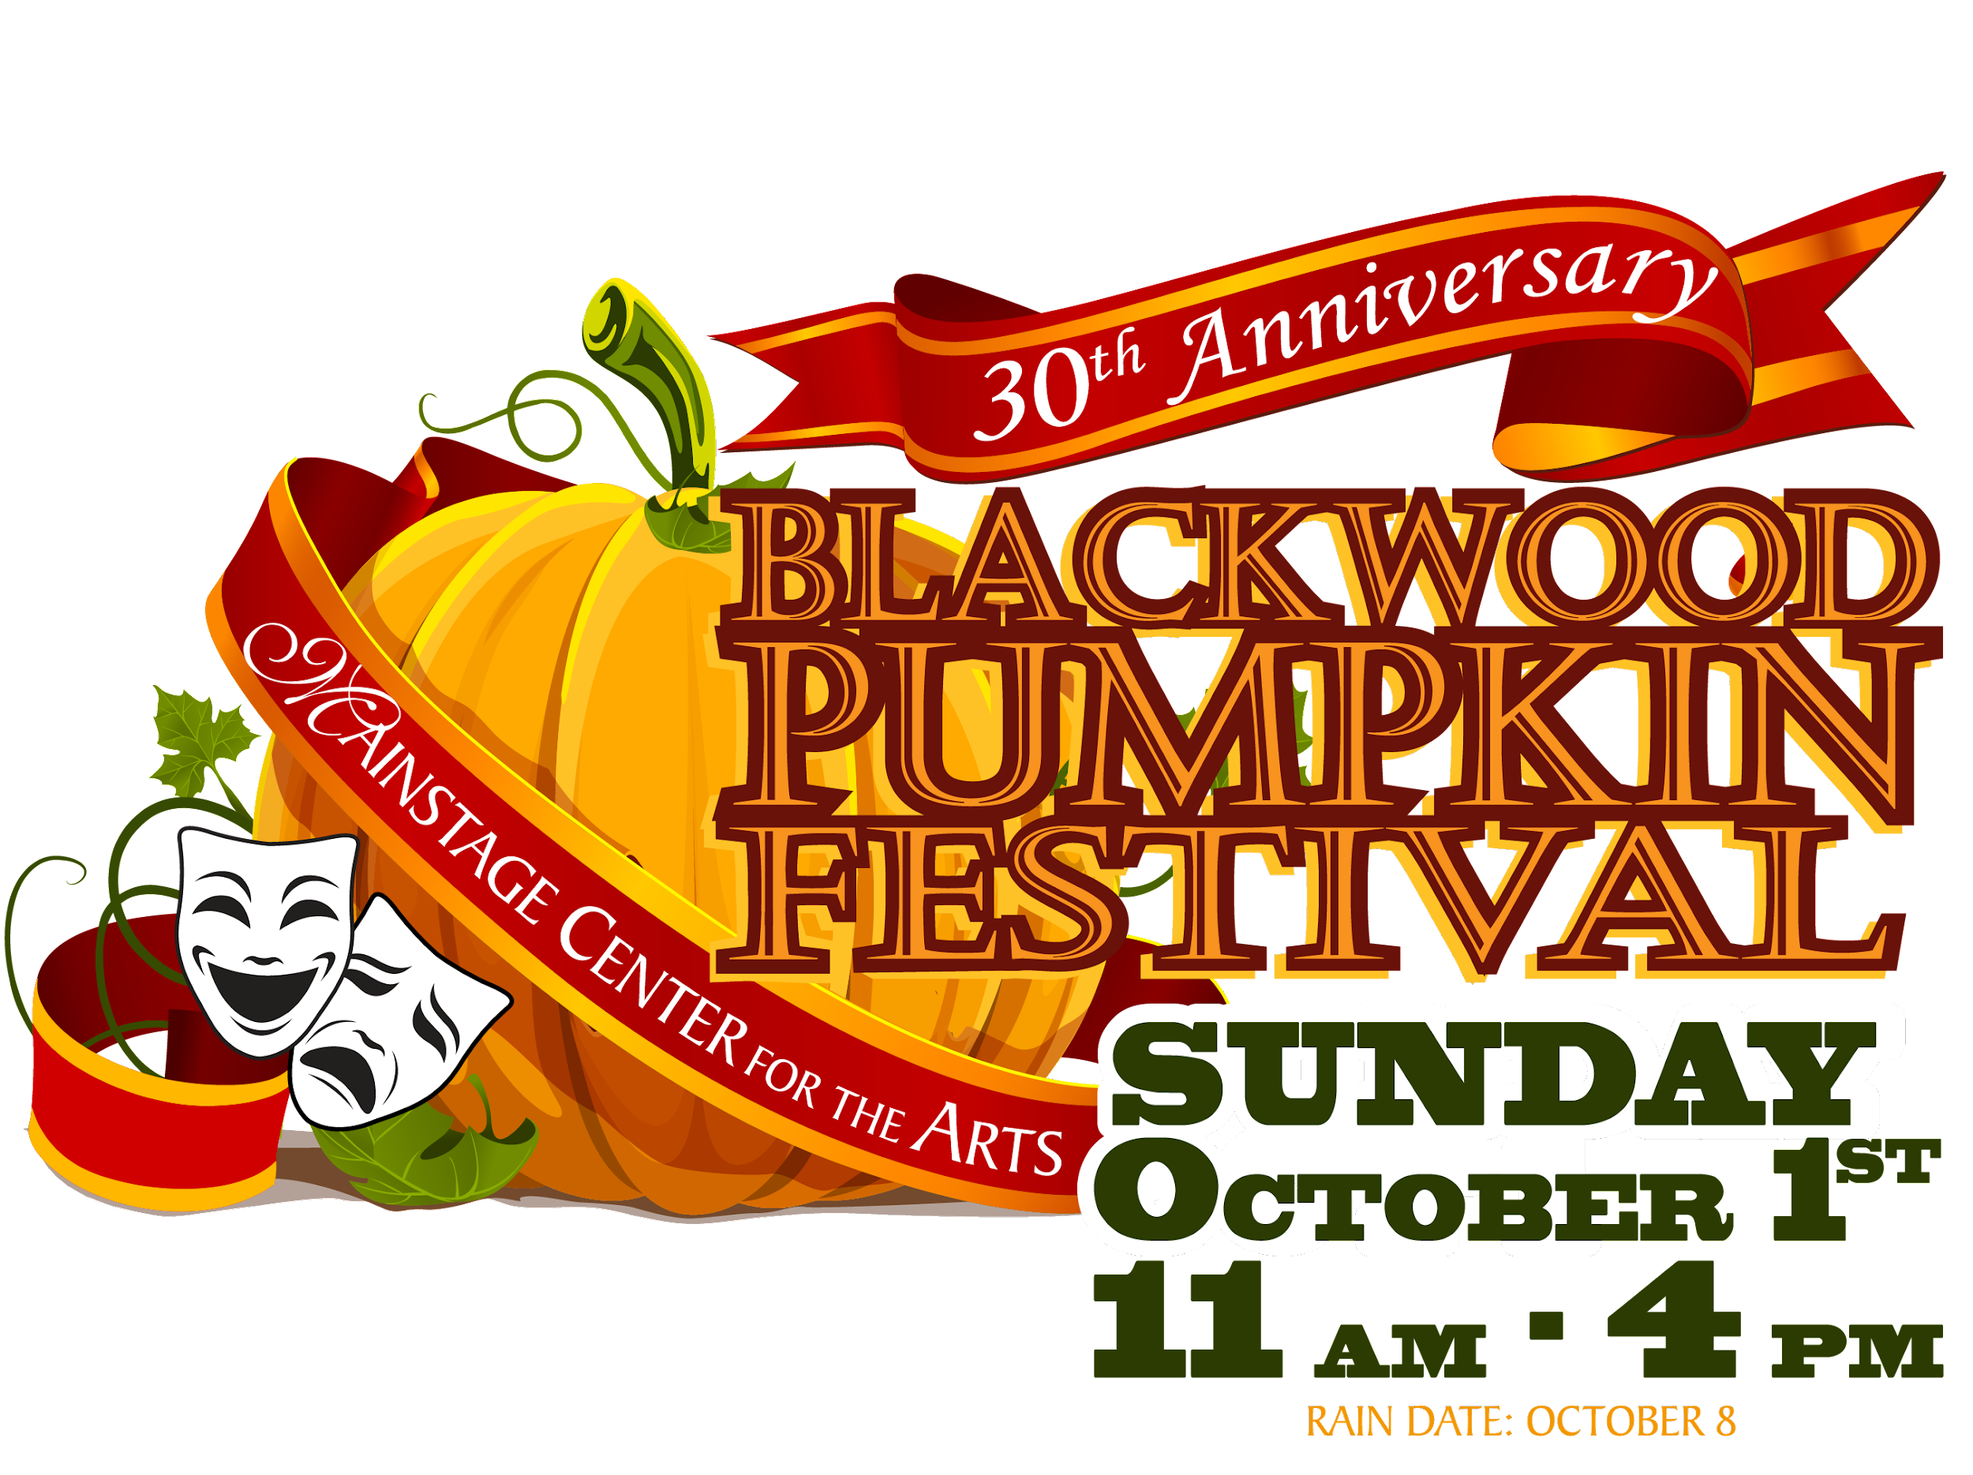
EXCITING BRANDING OPPORTUNITIES!

Dear Business Leader:

Looking for an exciting branding opportunity?
A chance to engage 8,000-plus South Jerseyans with your business?

Mainstage Center for the Arts, a non-profit 501(c)(3) performing arts organization, is proud to present the 30th Annual Blackwood Pumpkin Festival. As a Festival sponsor, you will reach many new customers.

On Sunday, October 1, 2023, from 11:00 AM to 4:00 PM, the festival will feature:

- Over 150 arts, crafts, and food vendors
- Quality family entertainment and events
- Games and amusements for children of all ages
- Special themed events and activities celebrating the 30th Anniversary of the Blackwood Pumpkin Festival

Exciting branding opportunities await your company!

FESTIVAL PLATINUM SPONSOR ($1,600)

- Logo Visibility on large Black Horse Pike Festival Banner.
- One High-Traffic Activity of Your Choice EXCLUSIVELY named for your company. (Pony Rides, Petting Zoo, Hayride, a Performance Space, Food Court or Amusement Zone). You may choose from this list based on availability.
- Hourly Sponsorship acknowledgement at all performance spaces.
- One Complimentary Vendor Space.
- Photo Opportunities for Company at Performance Stage.
- Additional Six-Month Sponsorship Visibility on Mainstage Website beginning 10/1/23.
- Eight (8) Complimentary Tickets to the Mainstage Holiday Show.
- Social Media Presence – 4 posts in August.
- Social Media Presence – 4 Posts in September (1 per week)
- Name & Logo on all festival maps.
- One Company Coupon Offering in Festival Handouts and Website.
- Name & Logo on Sponsor Honor Roll Signage.
- Name & Logo on Volunteer Festival T-shirts.

* PAYMENT MUST BE RECEIVED NO LATER THAN JULY 15, 2023 IN ORDER TO BENEFIT FROM ALL OF THE SPONSORSHIP PERKS LISTED ABOVE

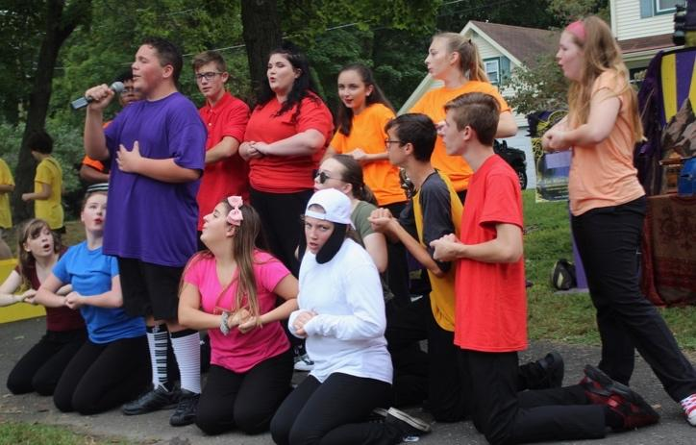

FESTIVAL GOLD SPONSOR ($1,000)

- One High-Traffic Activity of Your Choice EXCLUSIVELY named for your company. (Pony Rides, Petting Zoo, Hayride, a Performance Space, Food Court or Amusement Zone). You may choose from this list based on availability.
- Hourly Sponsorship acknowledgement at all performance spaces.
- One Complimentary Vendor Space.
- Additional Six-Month Sponsorship Visibility on Mainstage Website beginning 10/1/23
- Four (4) Complimentary tickets to the Mainstage Holiday Show.
- Social Media Presence - 2 posts in August.
- Social Media Presence - 4 posts in September (1 per week).
- Name & Logo on all festival maps.
- One Company Coupon Offering in Festival Handouts and Website.
- Name & Logo on Sponsor Honor Roll Signage.
- Name & Logo on Volunteer Festival T-shirts.

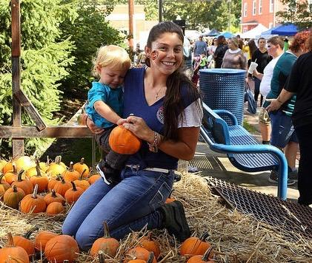

FESTIVAL SILVER SPONSOR ($600)

- Name & Logo visible at one event activity of your choice (Pumpkin Carving/Decorating, Scarecrow Building, Pumpkin Painting, Pet Parade, and House Decorating).
- Hourly Sponsorship acknowledgement at all performance spaces..
- Four (4) Complimentary tickets to the Mainstage Holiday Show.
- Social Media Presence - 3 posts in September.
- Name & Logo on all festival maps.
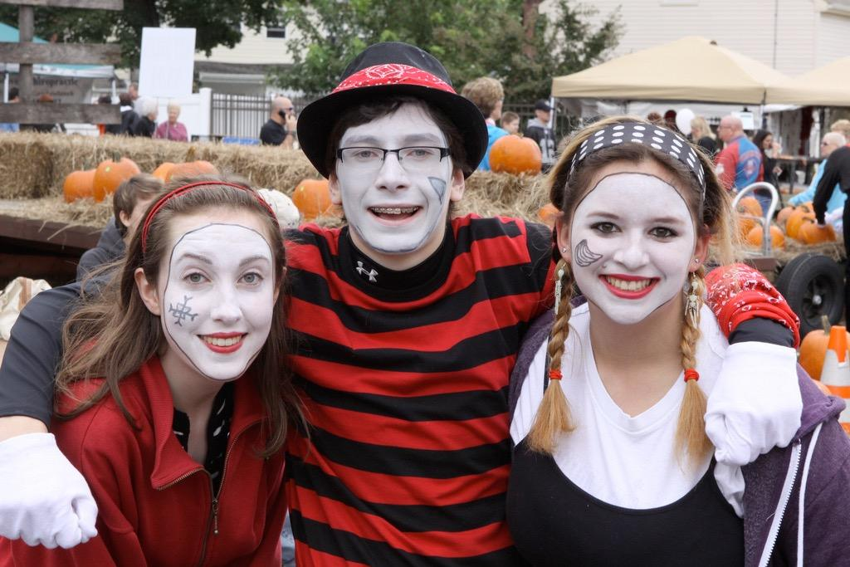
- One Company Coupon Offering in Festival Handouts and Website.
- Name & Logo on Sponsor Honor Roll Signage.
- Name & Logo on Volunteer Festival T-Shirts.

FESTIVAL BRONZE SPONSOR $250

- Name & Logo visible at one event activity of your choice. (Pumpkin Carving/Decorating, Scarecrow Building, Pumpkin Painting, Face Painting)
- Two (2) Complimentary tickets to the Mainstage Holiday Show.
- Social Media Presence - 1 post in September.
- Name & Logo on all festival maps.
- One Company Coupon Offering in Festival Handouts and Website.
- Name on Sponsor Honor Roll Signage.

Yes, please include me as a 2023 Pumpkin Festival Sponsor!
Company __________________________________________________________
Name______________________________________________________________
Street ______________________________________________________________
City/State/Zip Code___________________________________________________ Telephone_______________________ E-mail______________________________
I am excited to be a _____________ Sponsor (Please check one)
___ PLATINUM | ___ GOLD | ___ SILVER | ___ BRONZE
__ I would like a Vendor Space | —- I would like a Vendor Space | NA | NA
PLATINUM/GOLD SPONSORS
Please number your exclusively named event area in order of preference.
____ Hay Rides | ___ Petting Zoo | ___ Pony Rides
____ Amusement Zone | ___ Food Court | ___ Performance Space
SILVER/BRONZE SPONSORS
Please number the event area where you would like to have your logo and name posted in order of preference.
___ Scarecrow Building | ___ Pumpkin Painting | ___ Pet Parade
___ Pumpkin Painting/Carving Contest |  | ___ House Decorating Contest

Type of Payment:
_____Check enclosed payable to “Mainstage Center for the Arts”
_____Credit card (Visa /MasterCard)
Card Number_____________________________________Exp. Date___________ Signature________________________________________________________
Please return this sheet and check or credit card information to:
Mainstage Center for the Arts
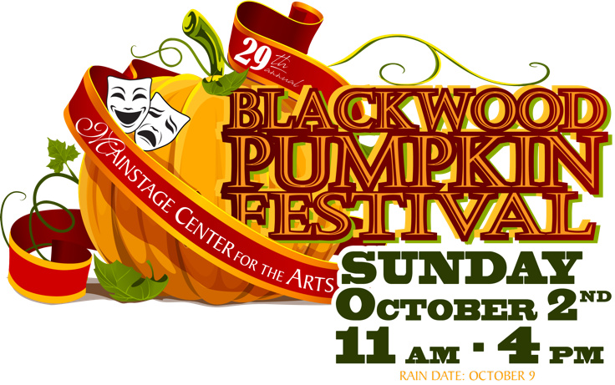
27 S. Black Horse Pike
Blackwood, NJ 08012

