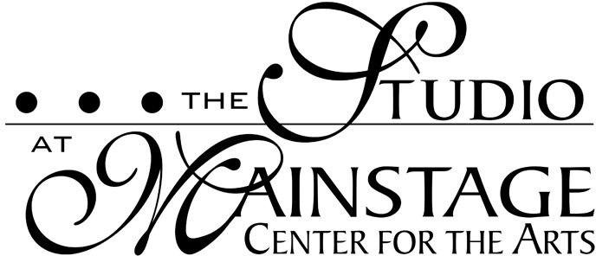

Financial Policies
2023-2024

We are so looking forward to having your student join us for the 2023-2024 Studio Season!

The Studio at Mainstage offers tuition in the form of a yearly fee per class, broken down into 9 installments to be paid on the first of the month between Sept. and May. The installment amount remains the same regardless of the number of classes held each month and is inclusive of any additional dress/tech rehearsal, recital, or performance preparations, etc. which may be held throughout the year. Classes culminate in a recital unless otherwise noted in description, this year that performance is scheduled for June 9, 2024.

If a discount is offered due to enrollment in multiple classes, adjustments will be made if a student withdraws from one of their classes.

It is the Mainstage policy that what you are purchasing is not an individual class at a time but a reserved place in that class. There is no provision for credit to be issued as tuition is not refundable, and no adjustments can be made for the number of classes in each month or days missed due to illness or personal inconveniences. If a class is canceled by Mainstage a make-up class will be offered.

Payment Plan:
A $25 registration fee and your first month’s tuition are due upon enrollment to hold your space in the class.

After the first month, Mainstage may automatically charge my debit/credit card on file the first of each month. If the card on file is declined, you will receive an email or phone call from the Business Manager. If payment is not made within 1 week, your child will receive a letter with payment options. After our second attempt, your child/children will not be allowed to take classes until payment is received.

In the event of payment by check: If the bank returns a check for insufficient funds, account holders will be charged a $35.00 service fee in addition to their regular monthly tuition payment. The total amount due must be delivered in cash directly to the Studio at Mainstage by the 10th of that month to retain their space.

Class Changes/Withdrawals:
A student who changes or withdraws from a class must do so by the 15th of the month by submitting a change or withdrawal from the class form either online or with our front desk administrator, or the next month’s full tuition will be automatically withdrawn from your account and not refunded or credited.

www.mainstage.org
+1 (856) 302-6485

27 S Black Horse Pike
Blackwood, NJ 08012

