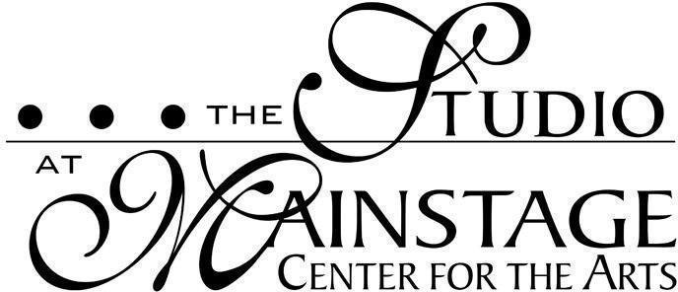

Cost per number of 1 hour classes (45 mins under age 6)
Paid over 9 installments September - May (no fee due in June).

Classes will be held Sept. 11, 2023 - June 9, 2024, culminating in a full studio recital held on June 9, 2024 (unless otherwise noted in the description). Installment amounts are not based on the number of classes held each month but are reflective of the total cost of the 33 sessions divided over 9 payments. Please see the full financial policy for more details. Multi-class discounts are for only one-hour classes and do not include performance classes.

 | Installment Amount
1 Class | $78
2 Classes | $145
3 Classes | $210
4 Classes | $280
5 Classes | $360
6 Classes | $435

Performance Classes:
Can be paid in full for a slight discount or in 9 installments.
 | Pay in Full | 9 Installment Rate
Musical Theatre Company | $1100 | $125
Acting Company (2 Sessions) | $1100 | $125
Both MT & Acting Company (All Sessions) | $2000 | $225
Acting Company (Single session) | $600 | $125 (5 installments)

Performance classes also require participation in Tech Week rehearsals in Lincoln Hall at Camden County College as well as for all performances.

Please continue below to view the Important Dates associated with the Performance Classes as mentioned above.
Important dates for 2023-2024 Performance Company Classes:
Musical Theatre Company 90 Minute Classes September through March, 2 Hour Classes in April and May.
Musical Theatre Company Tech Week: May 12 - 16, 2024 (Times TBD)
Performances: May 17 & 18, 2024 @ 7 pm

Acting Company Classes will be 90 minutes long except for tech weeks
Acting Company Session 1 Tech Week: January 7-10, 2024
Acting Company Session 1 Performances: January 11 & 12, 2024 @ 7 pm

Acting Company Session 2 Tech Week: June 9-13, 2024
Acting Company Session 2 Performances:
June 14 & 15, 2024 @ 7 pm

Private Lessons:
Purchased in 4 or 10 session packages.
Session Packages | 30 Minutes | 50 Minutes
4 Session | $175.00 (Price Per Session: $43.75) | $240.00 (Price Per Session: $60.00)
10 Sessions | $375.00 (Price Per Session: $37.50) (62.50 Total Savings) | $555.0 (Price Per Session: $57.50) ($45 Total Savings)

Private Lesson Teachers:
Courtney Bird - Private Acting
Allison Rossi - Private Piano
Shaun Yates - Private Voice

